**Amrita Vishwa Vidyapeetham**

**Amrita School of Engineering, Coimbatore**

**Department of Computer Science and Engineering**

**Topic: Linux Commands(Lab-1)**

------------------------------------------------------------------------------------------------**19CSE213 Operating Systems Laboratory – Linux Commands**

1. **uname -a :**

Displays the operating system name as well as the system node name, operating system release, operating system version, hardware name, and processor type.

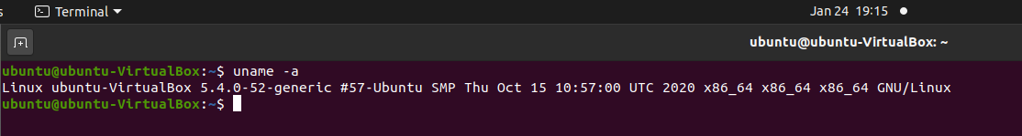

1. **cat :**

Cat(concatenate) command is very frequently used in Linux. It reads data from the file and gives their content as output.

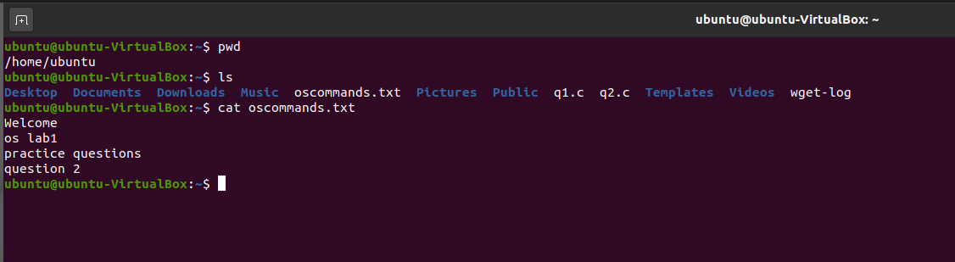

1. **uptime :**

The uptime command gives you information about the current time, online users, how long your system has been up and running, and the system load average.

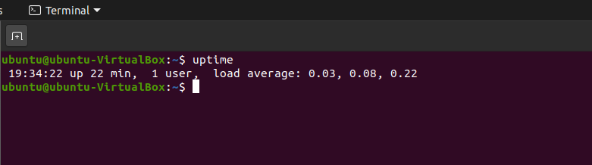

From the above code, the output has got four parts: Current time, Uptime, Number of Users, and average load as mentioned earlier.

1. **hostname :**

**hostname**is the program that is used to either set or display the current host, domain or node name of the system

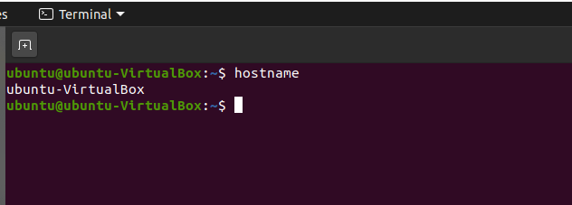

1. **cal :**

**cal** command is a calendar command in Linux which is used to see the calendar of a specific month or a whole year.

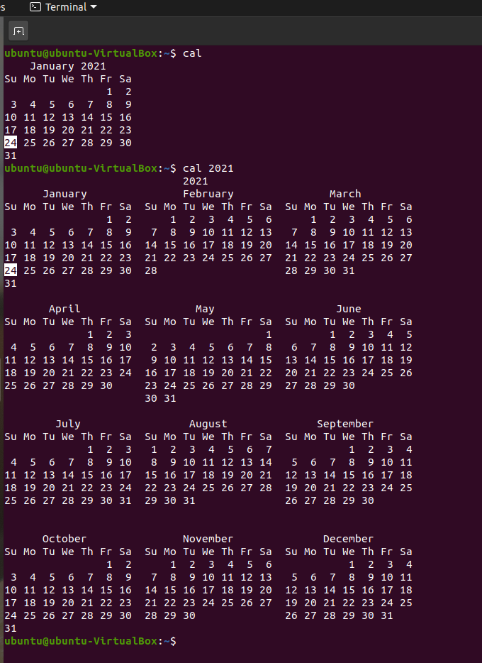

1. **w :**

**w** command in Linux is used to show who is logged on and what they are doing. This command shows the information about the users currently on the machine and their processes.

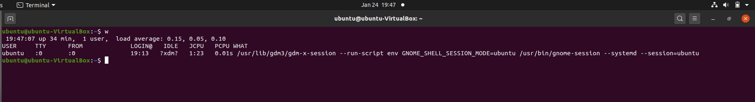

1. **whoami :**

The whoami command is a compound of the words “Who am I?” and prints the name of the user associated with the current effective user ID.

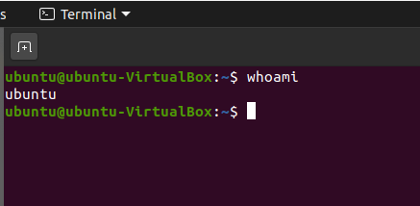

1. **free -h :**

the free command displays the total amount of free and used [physical](https://www.computerhope.com/jargon/p/physmemo.htm) and [swap](https://www.computerhope.com/jargon/s/swapfile.htm) [memory](https://www.computerhope.com/jargon/m/memory.htm), and the [buffers](https://www.computerhope.com/jargon/b/buffer.htm) used by the [kernel](https://www.computerhope.com/jargon/k/kernel.htm).

-h Show all output fields automatically scaled to shortest three [digit](https://www.computerhope.com/jargon/d/digit.htm) unit.

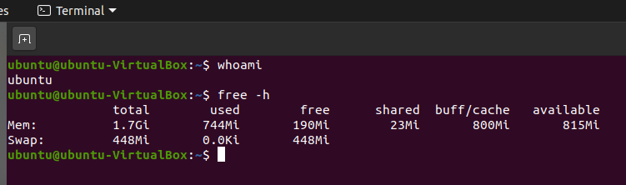

1. **top :**

The top command is used to display dynamic real-time information about running processes in the system.

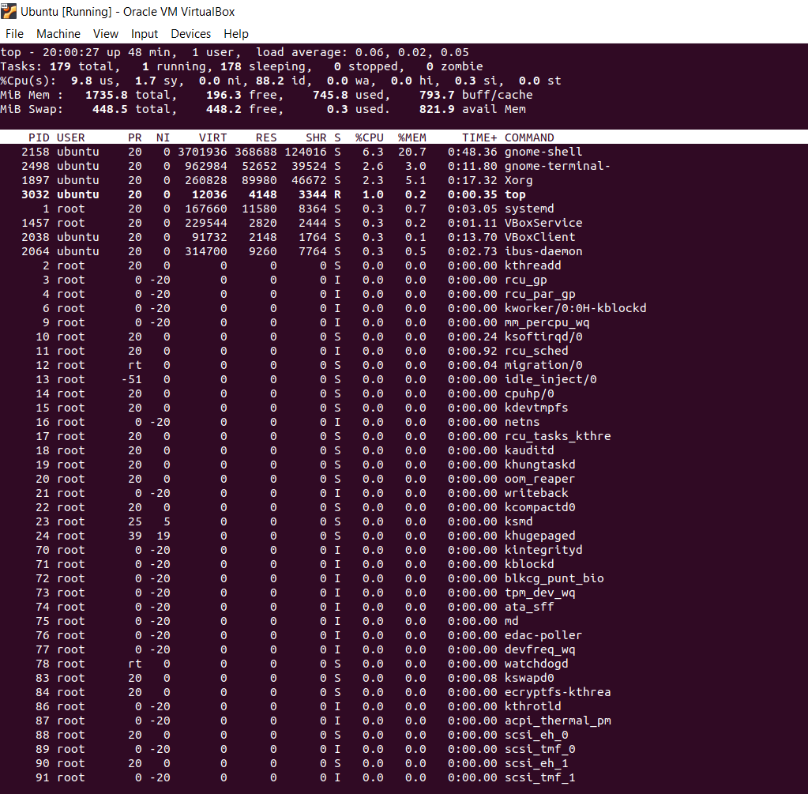

1. **lsof :**

**lsof** command stands for **List Of Open File**. This command provides a list of files that are opened.

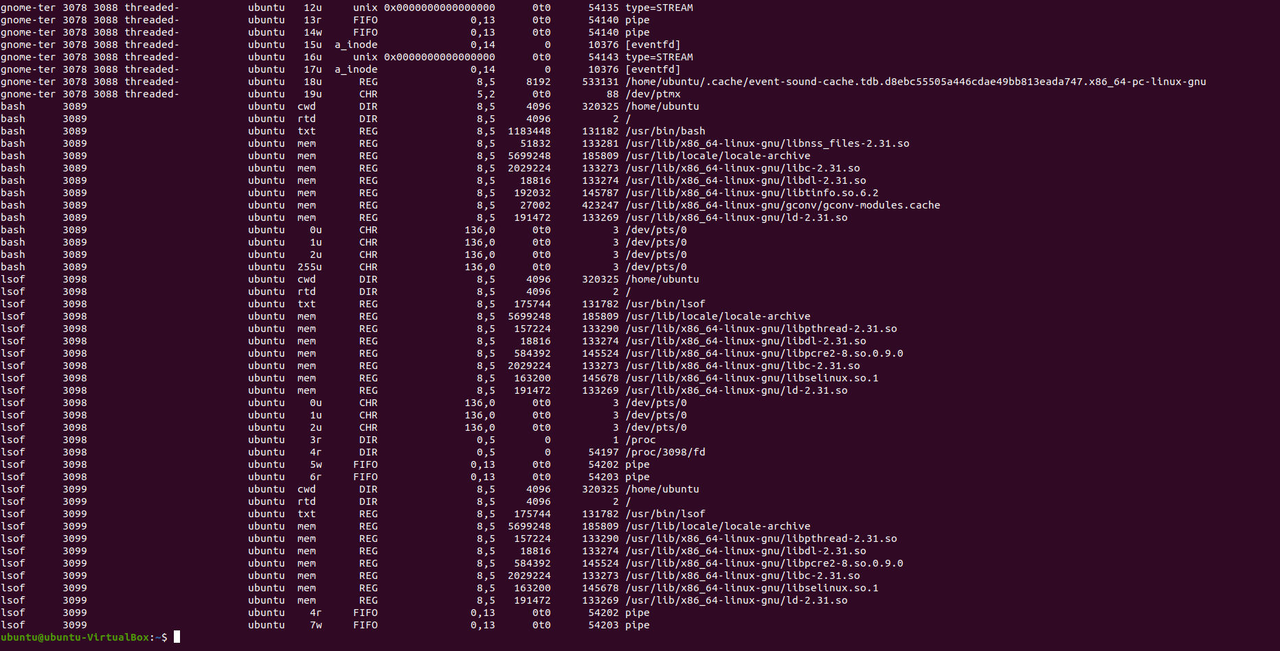

1. **rm :**

rm is a command-line utility for removing files and directories.

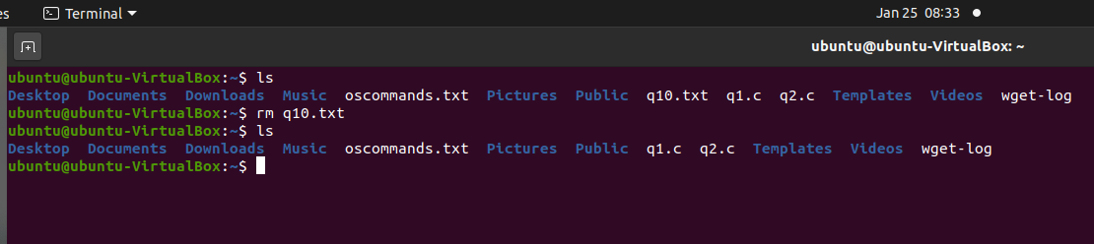

1. **cp file1 file2**

**cp file1 file2** is the command which makes a copy of **file1** in the current working directory and calls it **file2**

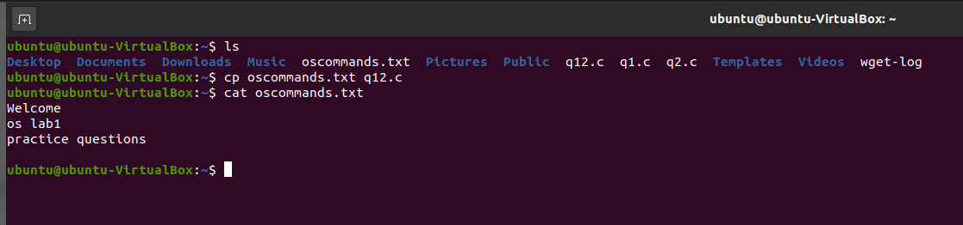

1. **touch :**

**touch command** is a way to create empty files

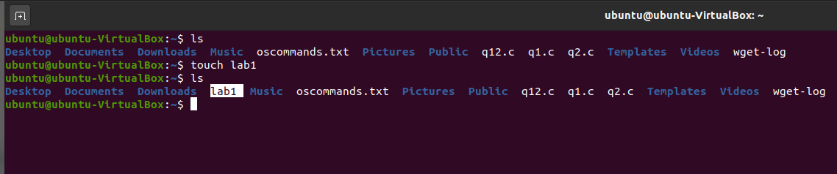

1. **ps -ef | grep processname :**

* The **ps** command, short for Process Status, is a command line utility that is used to display or view information related to the processes running in a Linux system.
* **-ef:**

It is used to view information related with the processes in the system.

* **Pipe(|)** is used to combine two or more commands to be executed simultaneously.
* Grep command is used to search for a particular word or alphabet in a file.

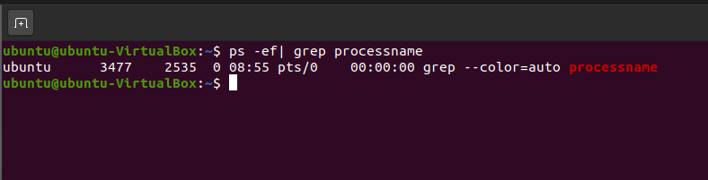

1. **ifconfig -a :**

To change the status of an interface, you use the command-line interface and the **ifconfig** command.

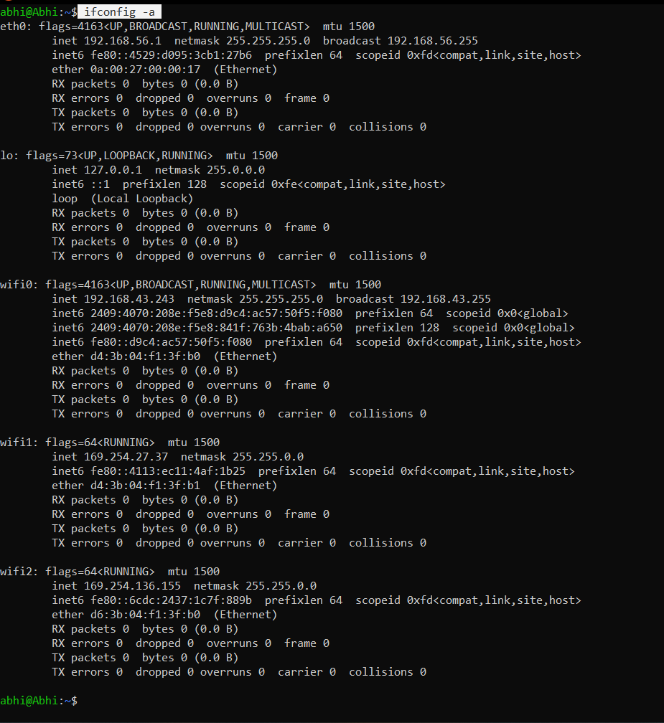

1. **hostname -i :**

It shows the ip address of your system.

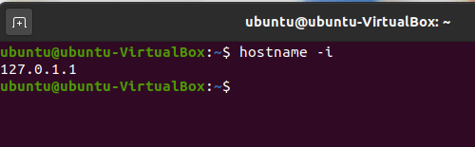

1. **locate name :**

locate command in Linux is used to find the files by name.

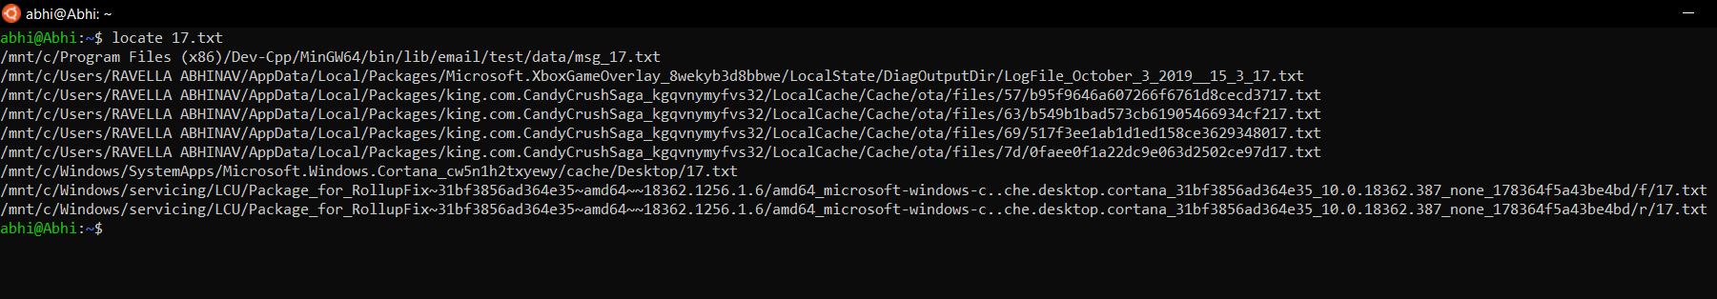

1. **df -h :**

It is used to check and display file system disk space usage.

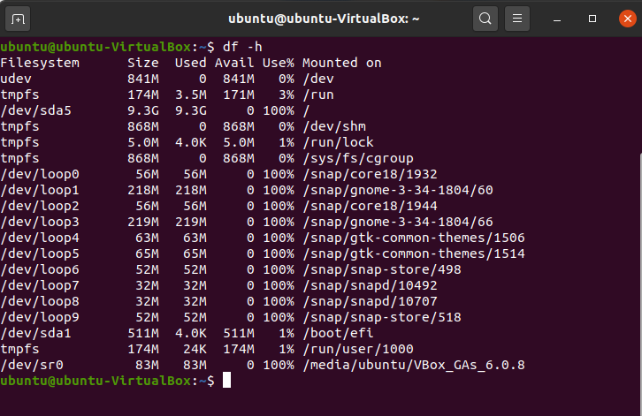

1. **du -ah :**

* du command displays the disk space used by all the files in the system.
* **-h option :**  -h option is used to produce the output in human ……………..readable format.
* **-a option :**  only the disk usage info of directory

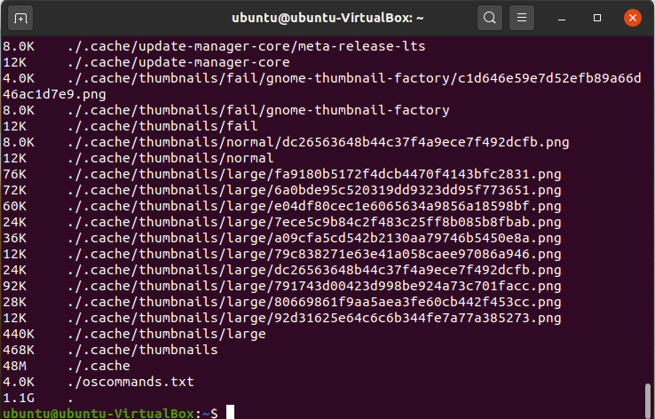

1. **man :**

used to display the user manual of any command that we can run on the terminal.

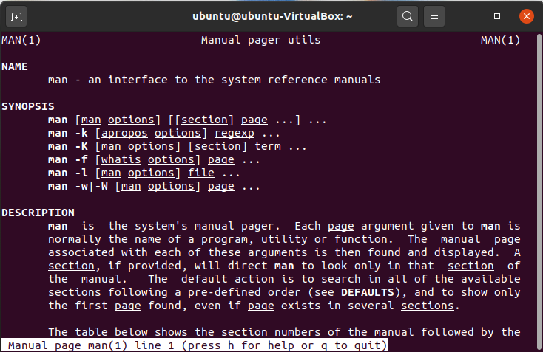

1. **sudo :**

The sudo command allows you to run programs as another user, by default the root user.

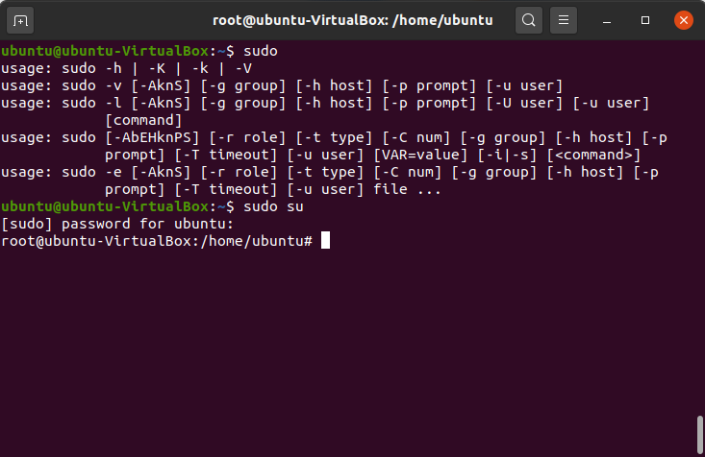

1. **find :**

Find can be used in a variety of conditions like you can find files by **permissions**, **users**, **groups**, **file type**, **date**, **size**, and other possible criteria.

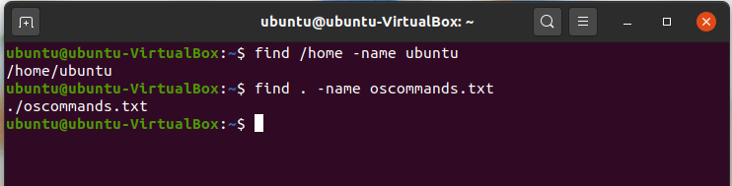

1. **free :**

The free command provides information about the total amount of the physical and swap memory, as well as the free and used memory.

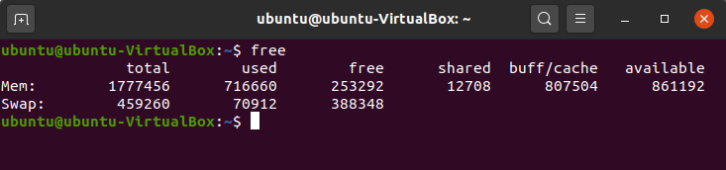

1. **kill:**

kill command sends a signal to a process which terminates the process.

* **kill -l :**To display all the available signals you can use below command option:

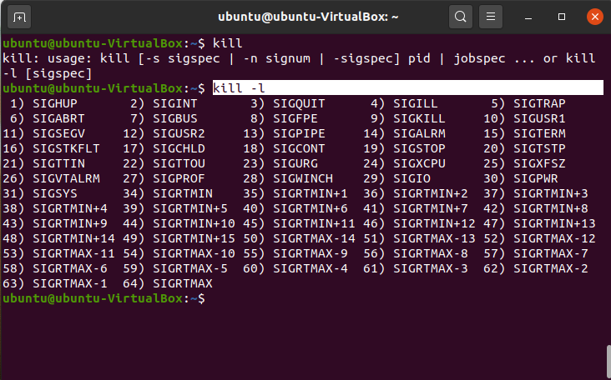

1. **chown :**

**chown** command is used to change the file Owner or group.

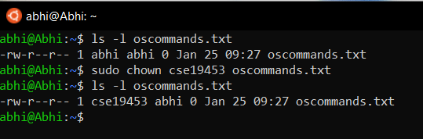

1. **chmod :**

* The chmod command is used to change the access mode of a file.
* The name is an abbreviation of change mode.

**Before :**

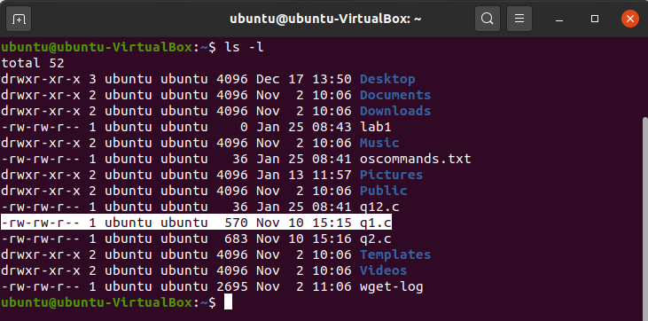

**After:**

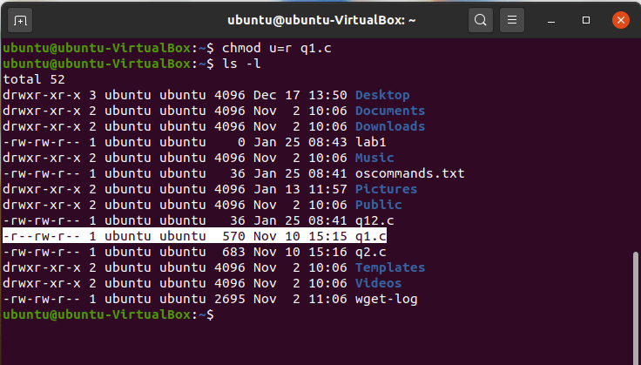

1. **chgrp :**

**chgrp command** in Linux is used to change the group ownership of a file or directory. All files in Linux belong to an owner and a group.

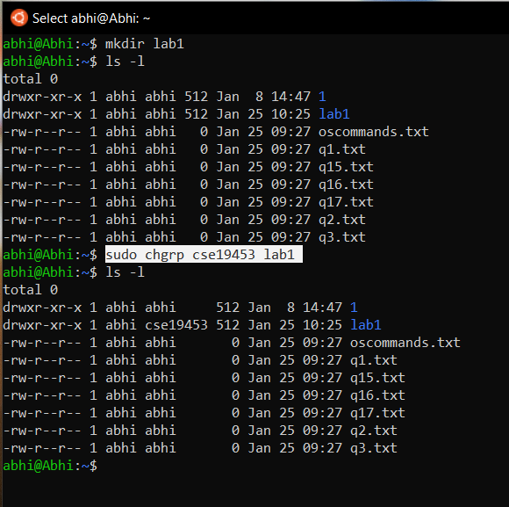

1. **wc :**

* wc stands for **word count**.
* It is used to find out number of lines, word count, byte and characters count in the files specified in the file arguments.

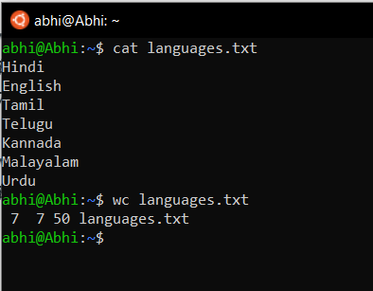

1. **diff :**

* diff stands for **difference**.
* This command is used to display the differences in the files by comparing the files line by line.

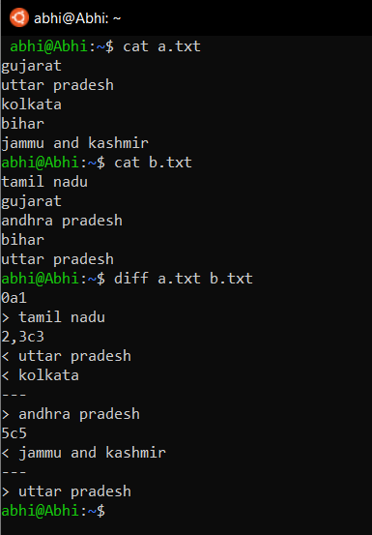

1. **uniq :**

The **uniq** command in Linux is a command line utility that reports or filters out the repeated lines in a file.

